Dear Editor,
Please find enclosed our manuscript entitled “ Machine learning prediction of the yield and BET area of activated carbon quantitatively relating to biomass compositions and operating conditions ” for your kind consideration to publish in Bioresource Technology as an article. We have chosen one suitable sub-classification “pyrolysis” from the new subject classification for our study focuses on the pyrolysis and activation process of biomass.
Applications of activated carbon cover a wide spectrum of applications as an adsorbent, namely, for wastewater treatment, removal of toxic gases from the environment, acting as a catalyst and catalyst carrier and various others pathways. The preparation of activated carbon from low-valued biomass not only has the advantage of resource utilization, but also achieves the purpose of energy conservation and emission reduction.
Biomass consists of cellulose, hemi-cellulose and lignin, whose scale spans multiple orders of magnitude. At the same time, the preparation methods for activated carbon include physical activation (CO₂ and steam) and chemical activation (H₃PO₄, KOH and ZnCl₂). Even for the same activator, if the operating conditions including the mass ratio, carbonization time, carbonization temperature, activation time and activation temperature are different, the properties of activated carbon still have a big gap. It is difficult to obtain the quantitative relationship between the yield and BET area of activated carbon and the compositions of biomass and operating conditions of biomass conversion by experiment.
Currently, the main products (bio-oil and gas) of biomass conversion can be partly predicted by the kinetic model, the BET area of solid products of biomass conversion such as char or activated carbon cannot be predicted. Nowadays, more and more artificial intelligence (AI) methods have been introduced into traditional research and some remarkable results have been obtained. Although some researchers have studied on the preparation of activated carbon under different operating conditions, for big data, machine learning methods based on complex biomass compositions and operating conditions to predict the yield and BET area of activated carbon simultaneously have not yet emerged.
Aiming at the problem that it is difficult for the existing models to obtain the yield and BET area of activated carbon quantitatively relating to biomass compositions and operating conditions. Herein, the data from 1995 to 2022 were collected by searching the database of Web of Science using keywords such as “biomass + activated carbon” or “biomass + porous carbon”. Meanwhile, we comprehensively analyzed and studied the above problems, through the Random Forest (RF) algorithm in machine learning method predicted the BET area and yield of activated carbon based on big data (more than 1500 datasets) (Scheme 1). In addition, mainly analysis the feasibility of preparing activated carbon from biomass and its derivatives containing multiple components under different physical and chemical activation conditions, and provided a practice application and guidance. As a result, different biomass compositions (ultimate analysis, proximate analysis and chemical analysis), operating conditions (mass ratio, carbonization time, carbonization temperature, activation time and activation temperature) under physical activation (CO₂ and steam) and chemical activation (H₃PO₄, KOH and ZnCl₂) were successfully used as input parameter to predict the yield and BET area of activated carbon by machine learning method. We believe that this manuscript is of great interest for the readership of Bioresource Technology.
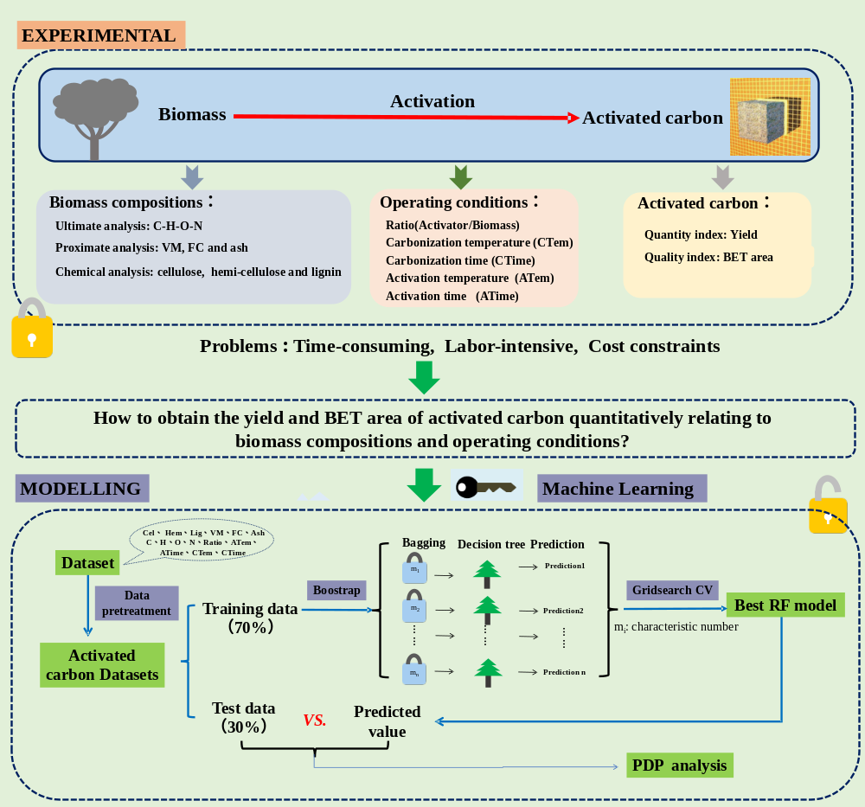
Scheme 1. The research framework of machine learning prediction of the yield and BET area of activated carbon quantitatively relating to biomass compositions and operating conditions.

This manuscript, or its contents in some other form has not been published earlier by any of the authors and is not under consideration for the publication in any other journal. All authors on this manuscript have seen and approved the submission of the manuscript. Moreover, the manuscript does not involve human subjects.

We suggest the following experts as potential referees of this manuscript:
1. Prof. Dr. Georgios Kontogeorgis (Email: gk@kt.dtu.dk), Center for Energy Ressources Engineering, Technical University of Denmark. Reason: His research is in the fields of thermodynamics, artificial intelligence, fuel engineering.
2. Prof. Dr. Leonidas Matsakas (Email: leonidas.matsakas@ltu.se), Department of Civil, Environmental and Natural Resources Engineering, Luleå University of Technology. Reason: His research mainly focuses on biomass utilization such as pyrolysis, gasification, biomass biorefinery.
3. Prof. Dr. Yuefeng Liu (Email: yuefeng.liu@dicp.ac.cn), Dalian Institute of Chemical Physics, Chinese Academy of Sciences. Reason: His research mainly focuses on biomass utilization such as pyrolysis, gasification, carbon in catalysis, CO/CO₂ hydrogenation.
4. Prof. Dr. Honglai Liu (Email: hlliu@ecust.edu.cn), School of Chemistry and Molecular Engineering, East China University of Science and Technology. Reason: His research focuses on thermodynamics, artificial intelligence, molecular simulation.
5. Prof. Dr. Shuangliang Zhao (Email: szhao@gxu.edu.cn), School of Chemistry and Chemical Engineering, Guangxi University. Reason: His research focuses on thermodynamics, artificial intelligence, molecular simulation.
6. Prof. Dr. Liangliang Huang (Email: HLL@ou.edu), School of Chemical, Biological and Materials Engineering, University of Oklahoma. Reason: His research focuses on molecular simulation, artificial intelligence and thermodynamics.

This work was funded by the National Natural Science Foundation of China (22178391, 21878337, 22178160, 21978128), Jiangsu Agriculture Science and Technology Innovation Fund (JASTIF) (CX(21)3075), Demonstration Project of Modern Agricultural Machinery Equipment &Technology in Jiangsu Province (NJ2022-11) and Guangdong Provincial Key Laboratory of Distributed Energy Systems (2020B1212060075).

Thank you for considering our manuscript for publication in Bioresource Technology.
With warm regards,

Hongliang Qian

